6A^{th} Grade: Unit 15, Lesson 7

- A bag has 3 red marbles, 4 blue marbles, 3 black marbles, and 2 yellow marbles. If the game requires you to pull a marble without looking from the bag, what is the theoretical probability of pulling a red marble.

$\frac{3}{12}$ or $\frac{1}{4}$

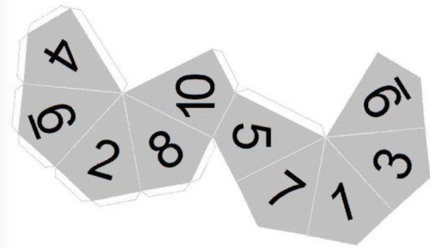
- The faces of a ten-sided die are shown. What is the probability of rolling a 3, 4, or 5 on the die?

$$\frac{3}{10}$$

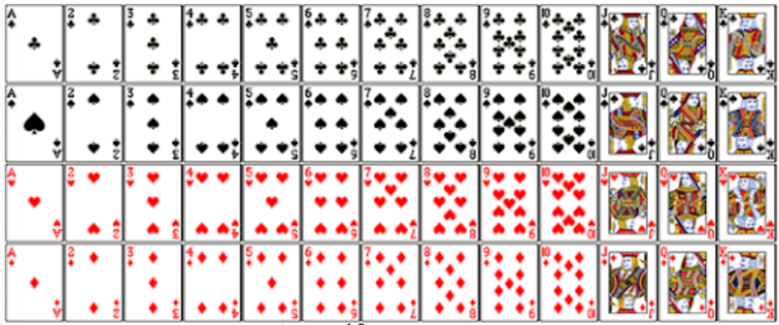
- A standard deck of cards includes the following 52 cards:
How can you represent $\frac{10}{13}$ of the deck of cards?

The first 10 columns of the diagram of the deck.

